Day-3 Revisit

1. Git – Version control System
2. Unix Commands (ls, mkdir, cd, help, info, man, pwd, date, time….)

Different ways of using Git

1. Using git bash (CUI) – Similar to command prompt in windows/ similar to terminal in mac
2. Using Cygwin
3. Using git-gui (Graphical user Interface)

Three Tools Needed for this week1

1. JDK 1.8 (Java 8)
2. Eclipse EE (IDE – Integrated Development Environment) - Java Program Development
3. Git-SCM – Git-Source Code Management (Version Control Tool)

In VS Code – IDE – Compatible with all programming languages (html, css, js, java, php, python)

It has various extensions which supports many programming languages and provide many tools which will make development of project very easier.

Github – It’s a cloud based version control system.

Apple iPhone 10 – last year

Apple iphone 11 – this year

Apple iphone 12 – next year

Windows 3.2 -- Less features

Windows 95 -- more features

Windows 98 -- more & more features

Windows me (Millennium Edition) – enhancements

Windows xp

Windows vista

Windows longhorn

Windows 7

Windows 8

Windows 8.1

Windows 10

Windows 11

Github –

My First Computer – It was a gift to me.

It was a x386 processor with 6 GB of Hard disk and the monitor is 3 color (RGB) CRT monitor.

It was a Pentium -II with 80GB HDD, 512mb RAM, CD-Drive, No web cam, External Speaker – I bought it during my college days

Creating an Account in Github

Step 1) Open github.com in browser.

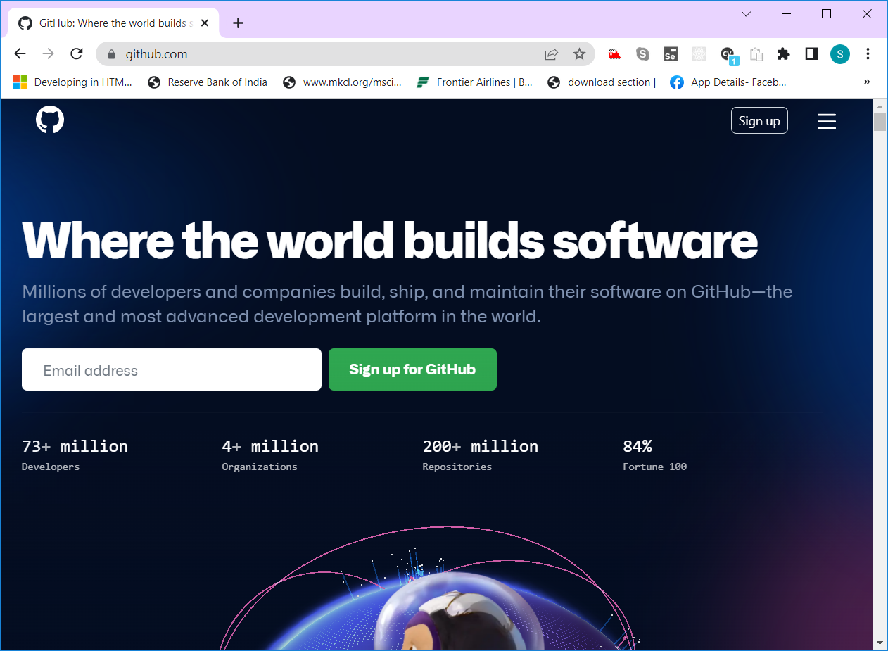

Step 2) Click on “Signup” button

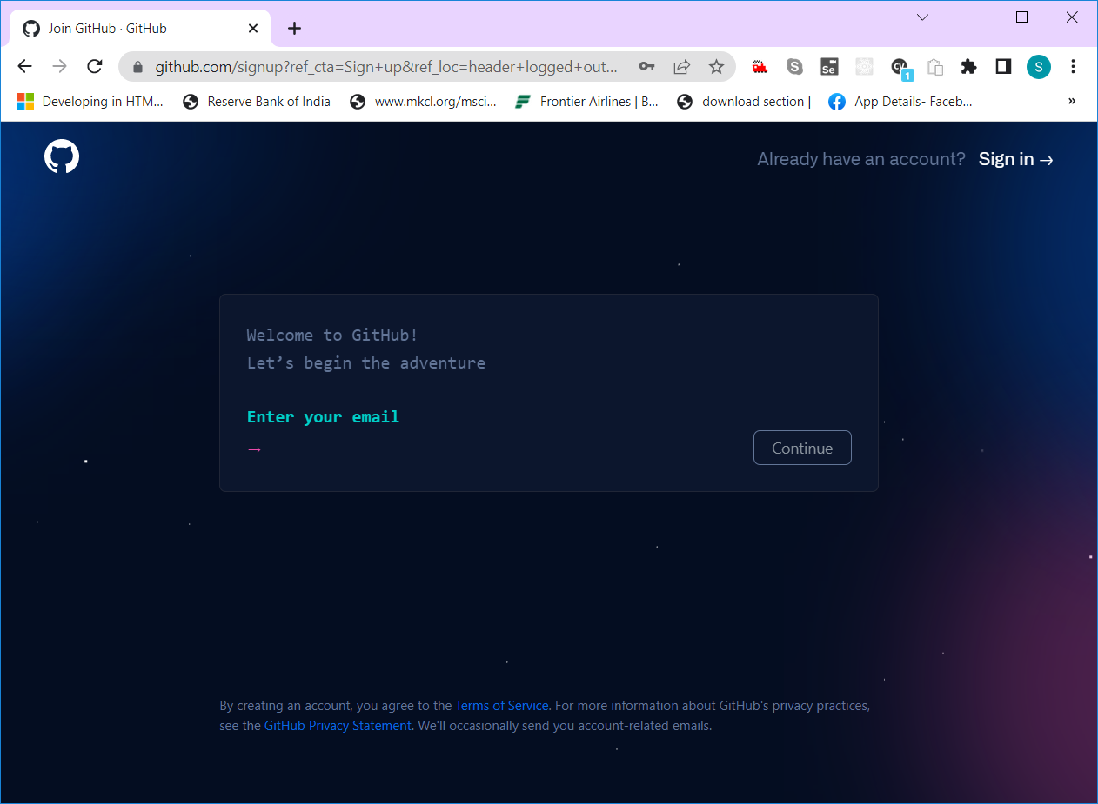

Step 3) Once after entering email, click on continue button & type password. Then select a username

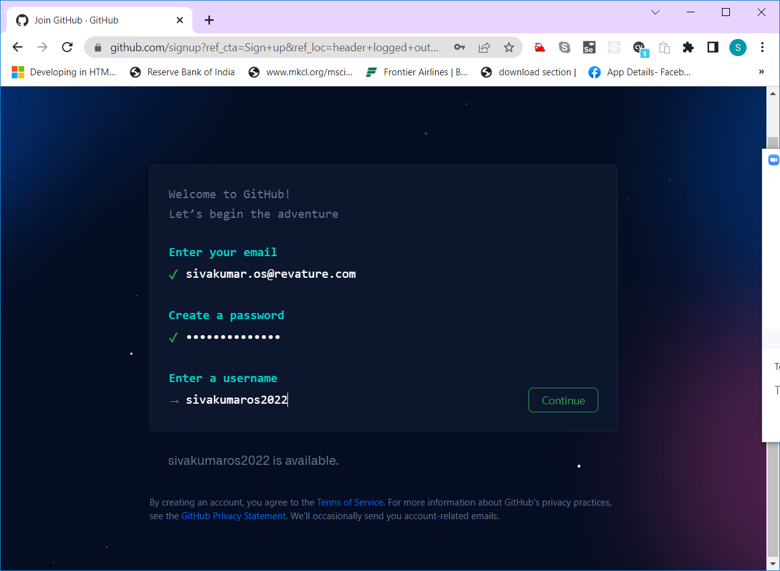

Step 4) Click on “Continue” button to accept/reject product updates email

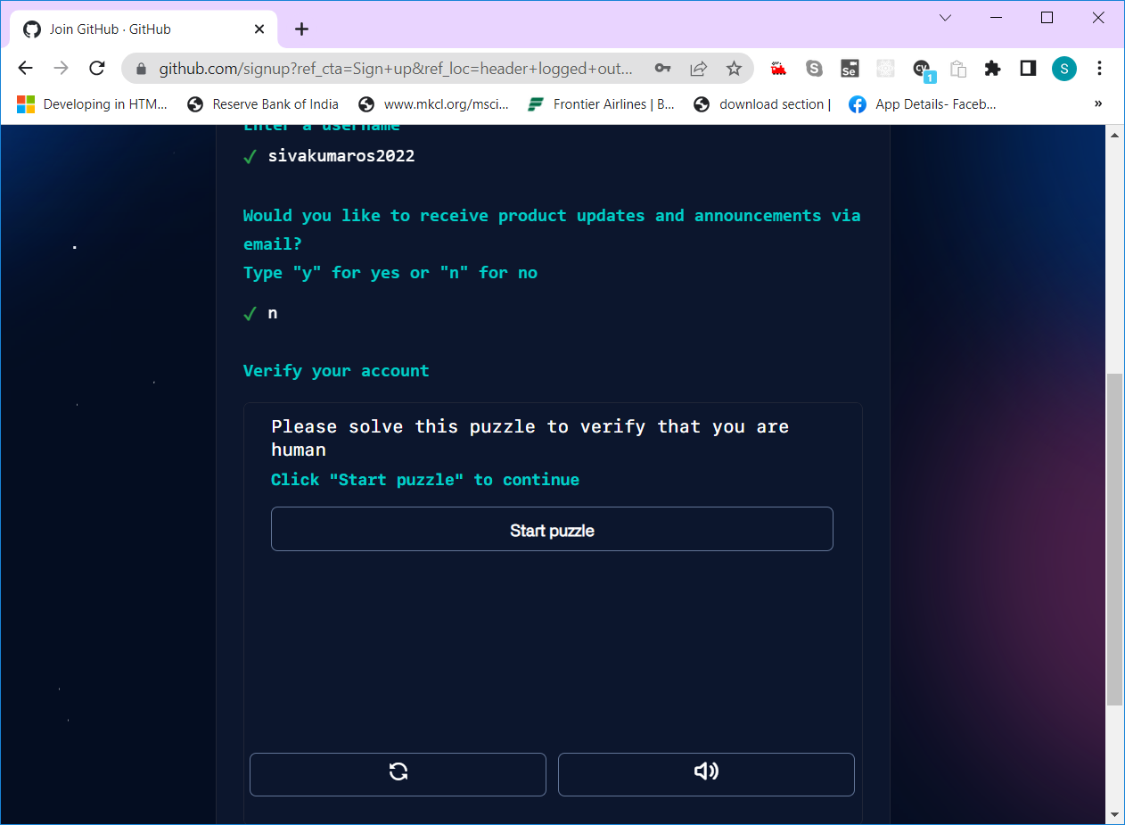

Step 5) Verify that you are a human by resolving a puzzle

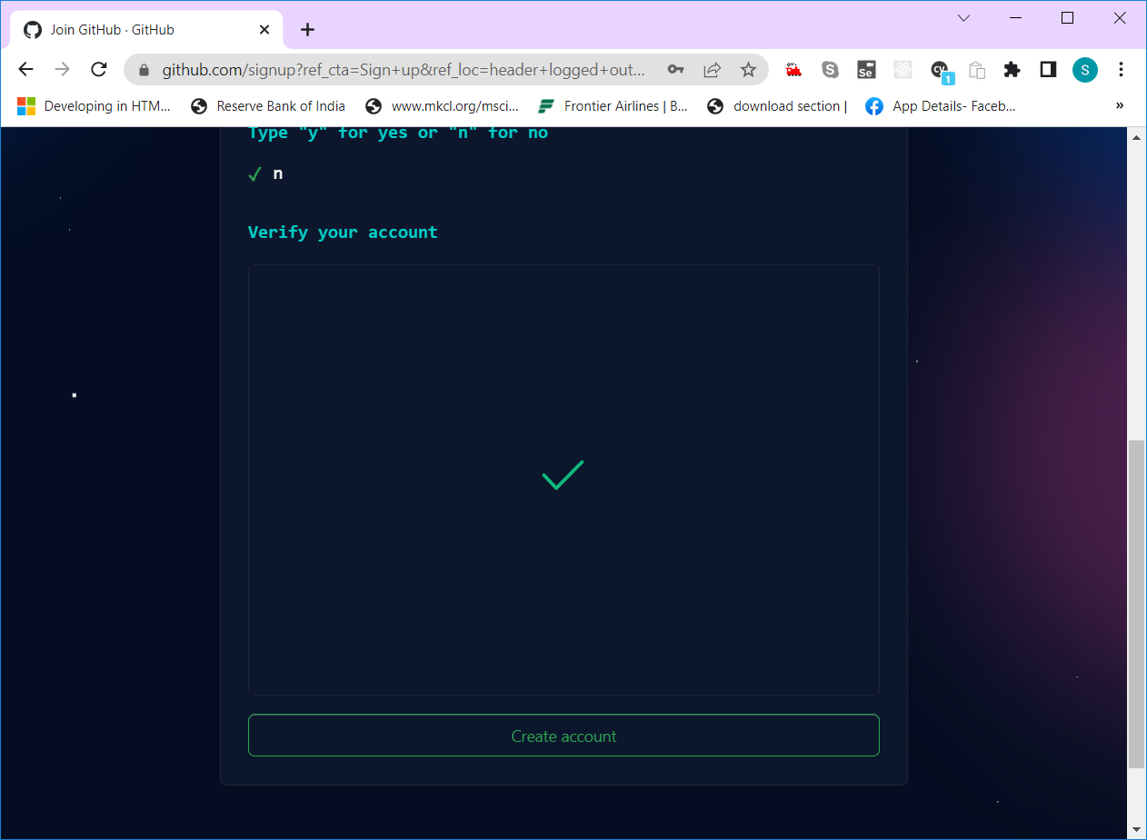

Step 6) Click on “Create Account” button to proceed and enter the launch code which you received in the email that you have used to signup.

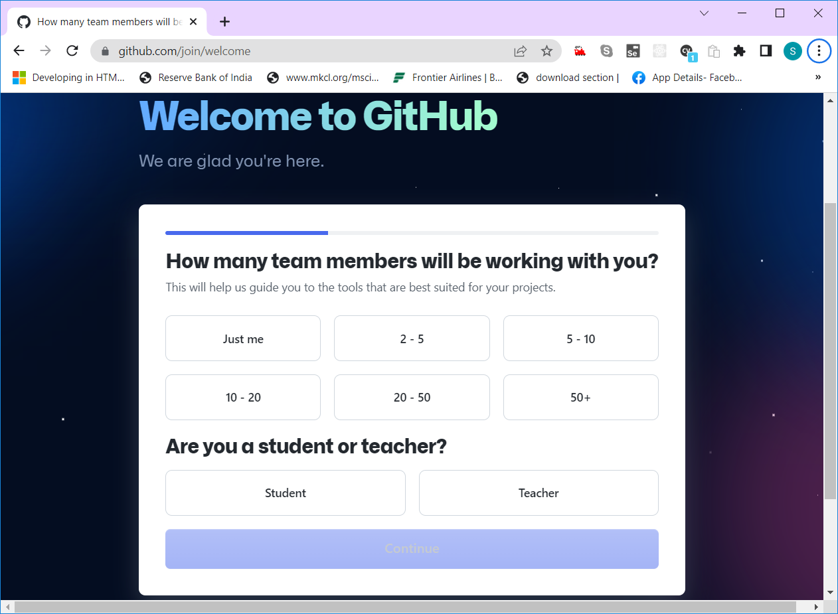

Step 7) Select team members, and role (Student/teacher) then click continue button and then click on “Continue for Free” button

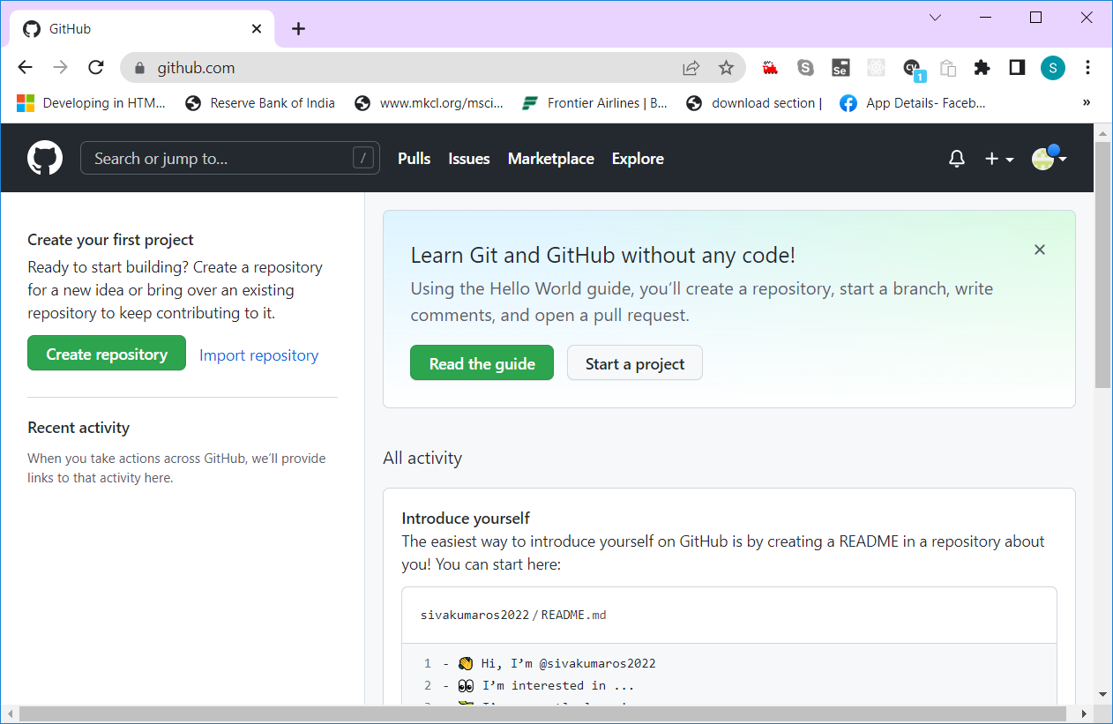

Repository – It’s a git term – Actually it’s a location/folder in which one save all the source code of the application.

1. Local repository (It’s a Folder in your file sytem)
2. Remote Repository (it’s a url in your github account)

Steps to create a remote repository.

1. Sign-in to Github.com using your username and password.

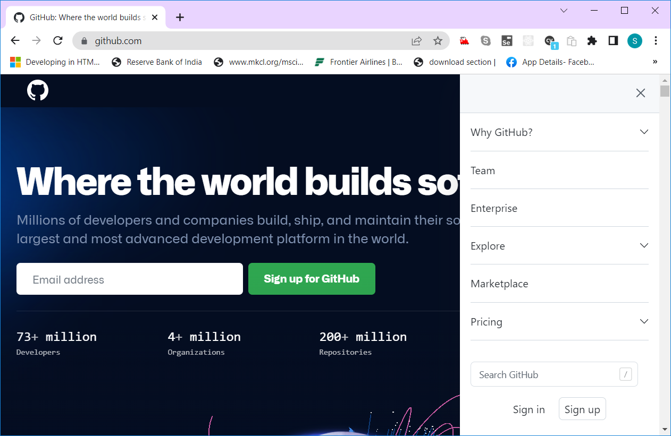

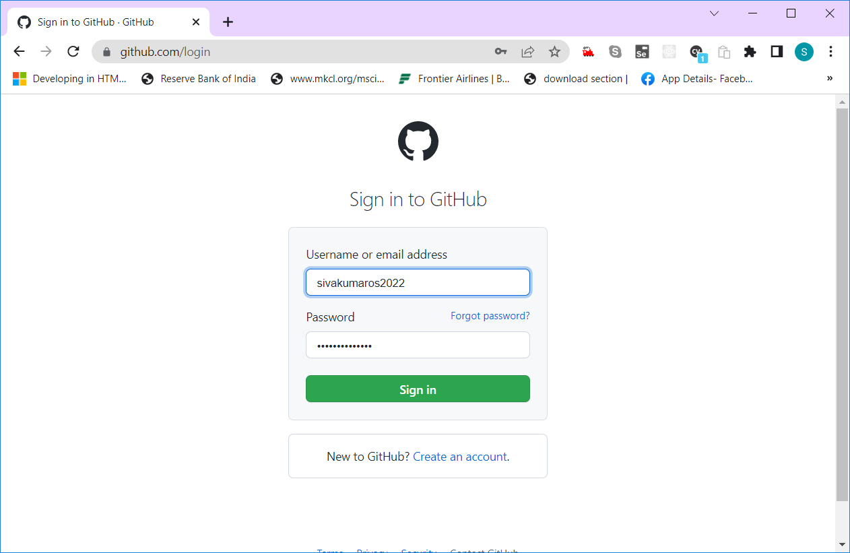

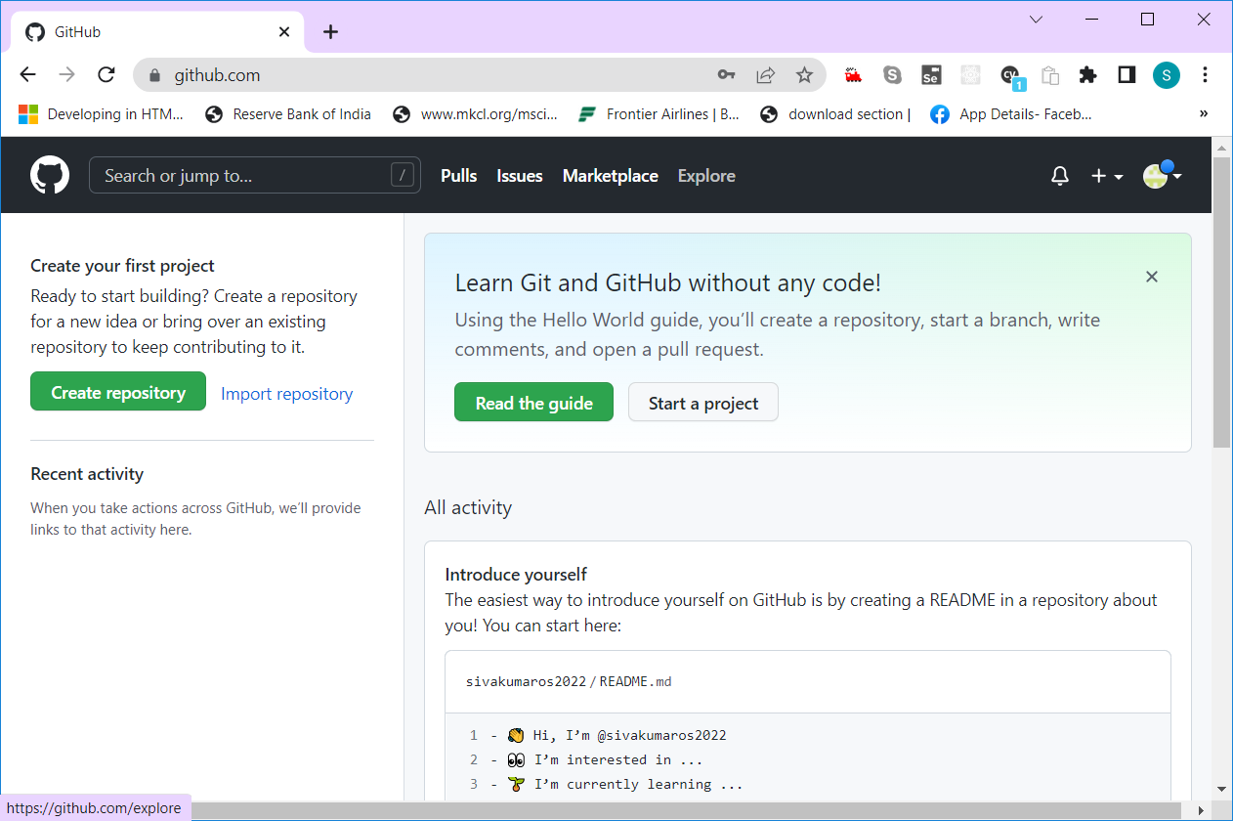

1. Click on “Create Repository” button

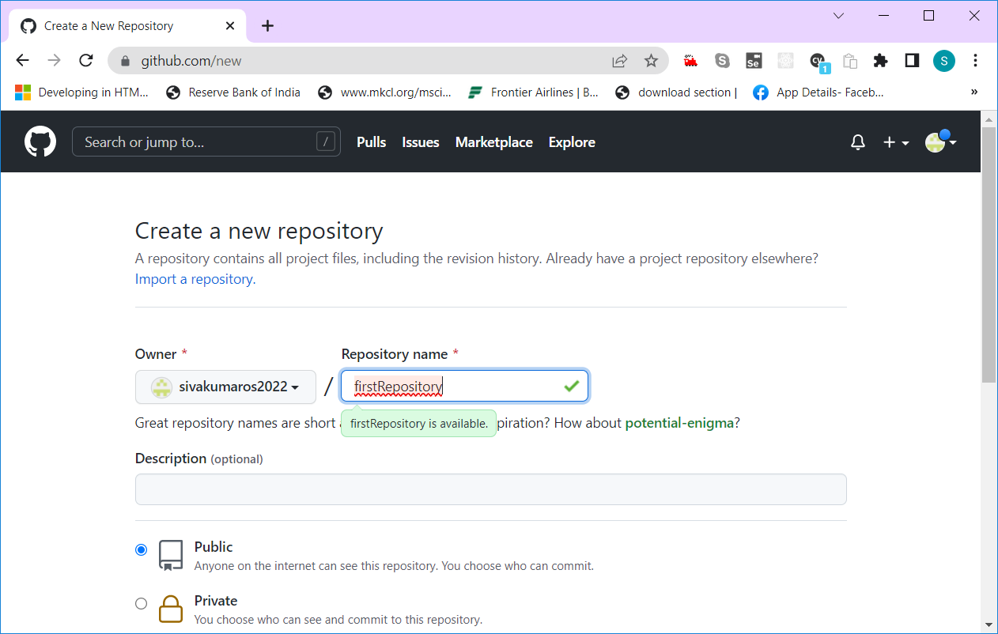

1. Enter the name for your repository in the given text box and select the option to use it as a public/private repository

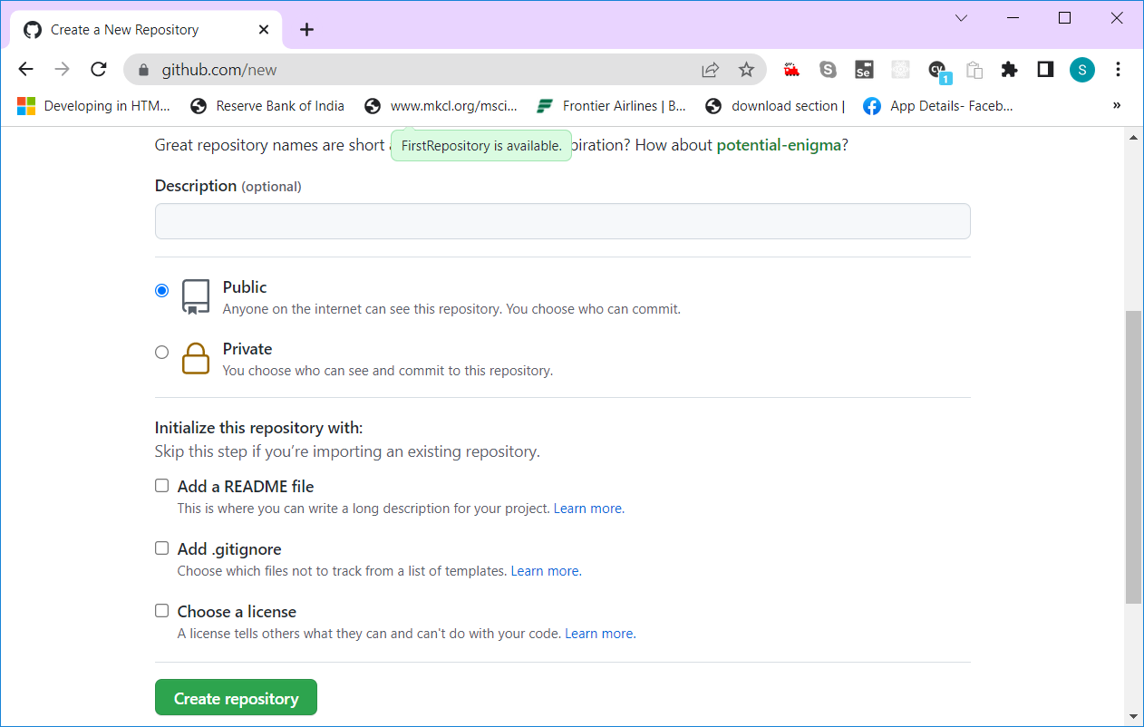

1. Click on “Create repository” button

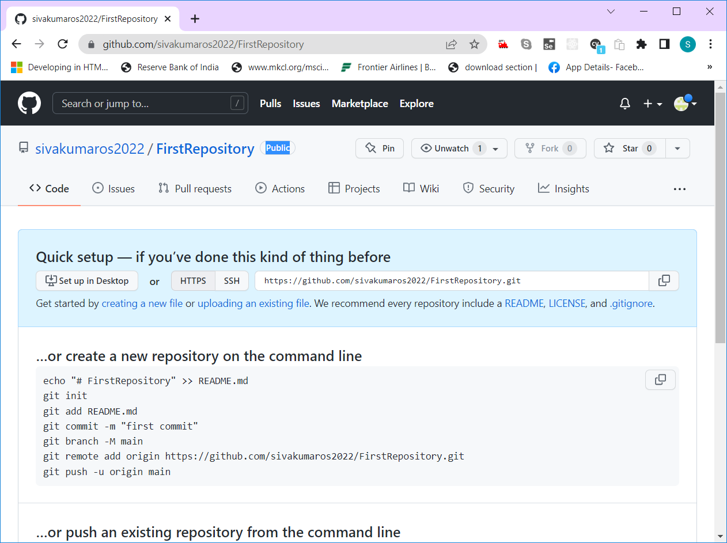

1. You can see github repository url -- <https://github.com/sivakumaros2022/FirstRepository.git>
2. The repository that we create in github, is called remote repository
3. The remote repo url consist of github.com + github_username + repo_name.git
4. Github – is a web/cloud based version control tool, which is used to collaborate, manage and track changes to remote repos.
5. Cloning a repo – Creating a copy of remote repo --- to local repo
6. Forking a repo – Creating a copy of other person’s public repo to my remote repo
7. To Upload a file/folder from your system to the github repository, just select and drag that file/folder to github by selecting “Uploading an exiting file” link

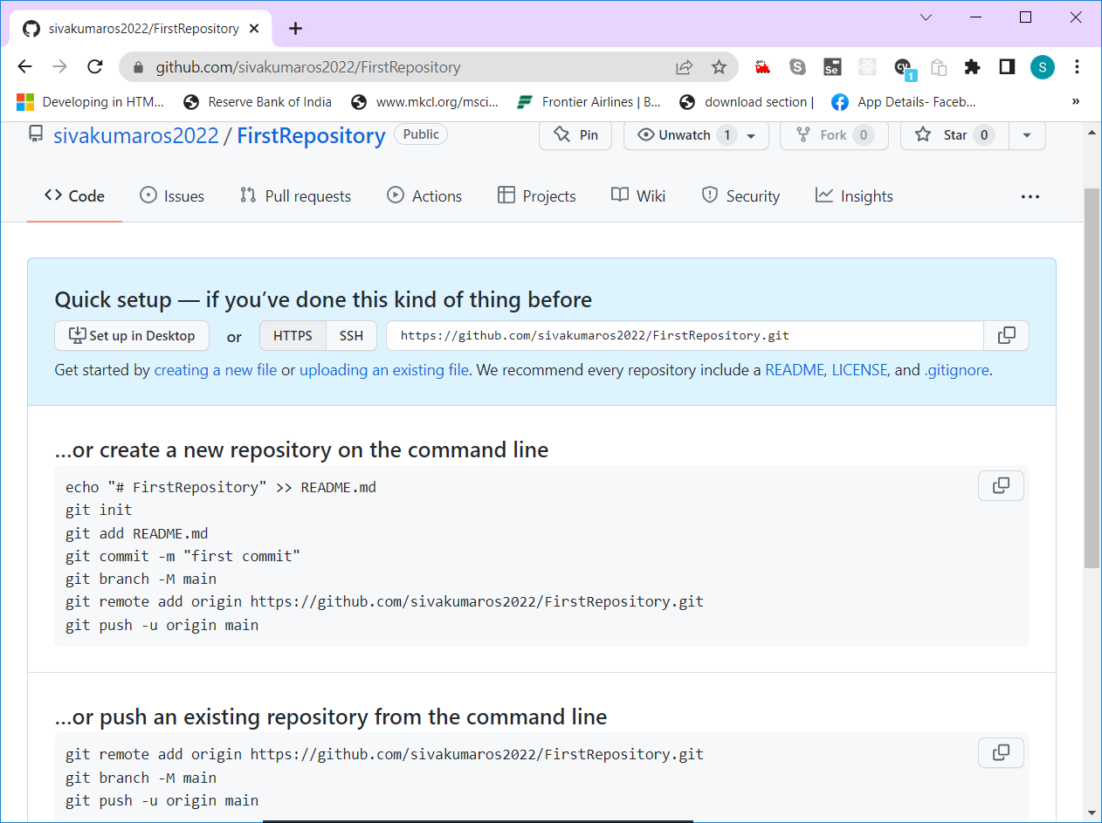



1. Simply drag & drop the file/folder in the following screen

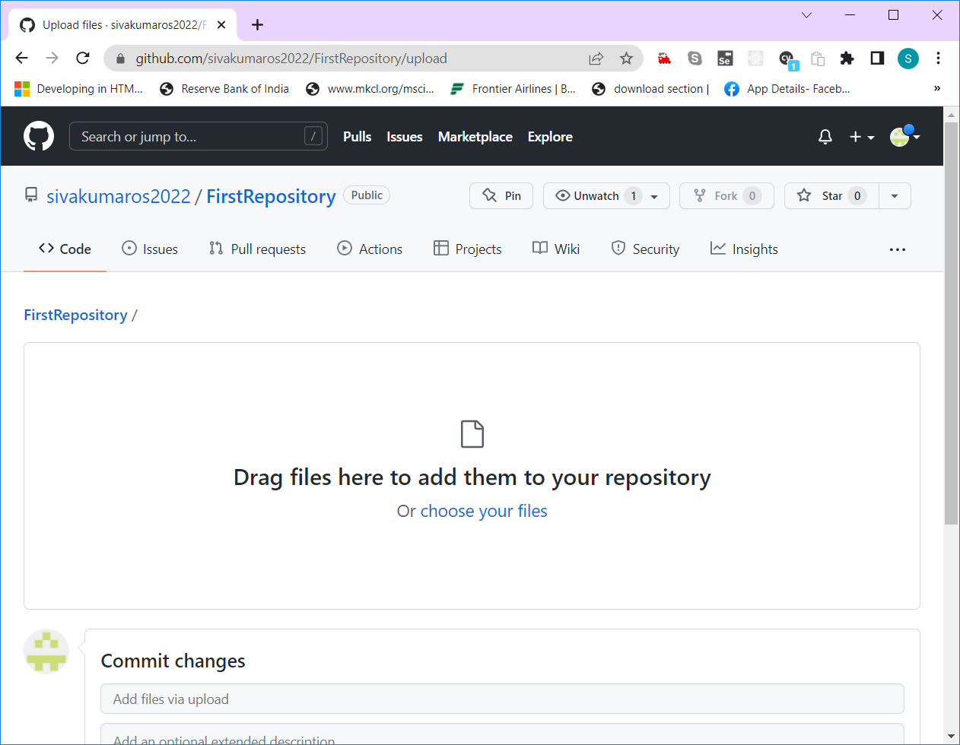

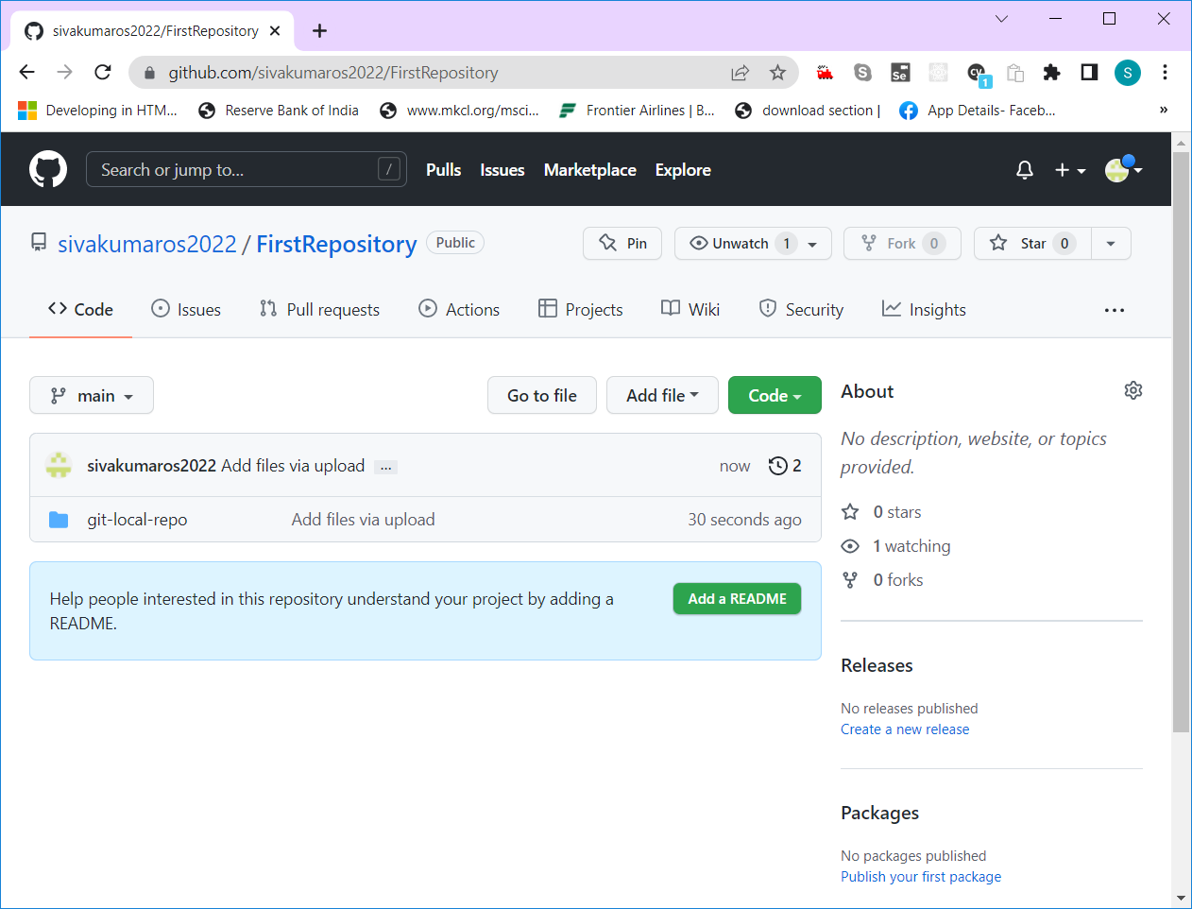

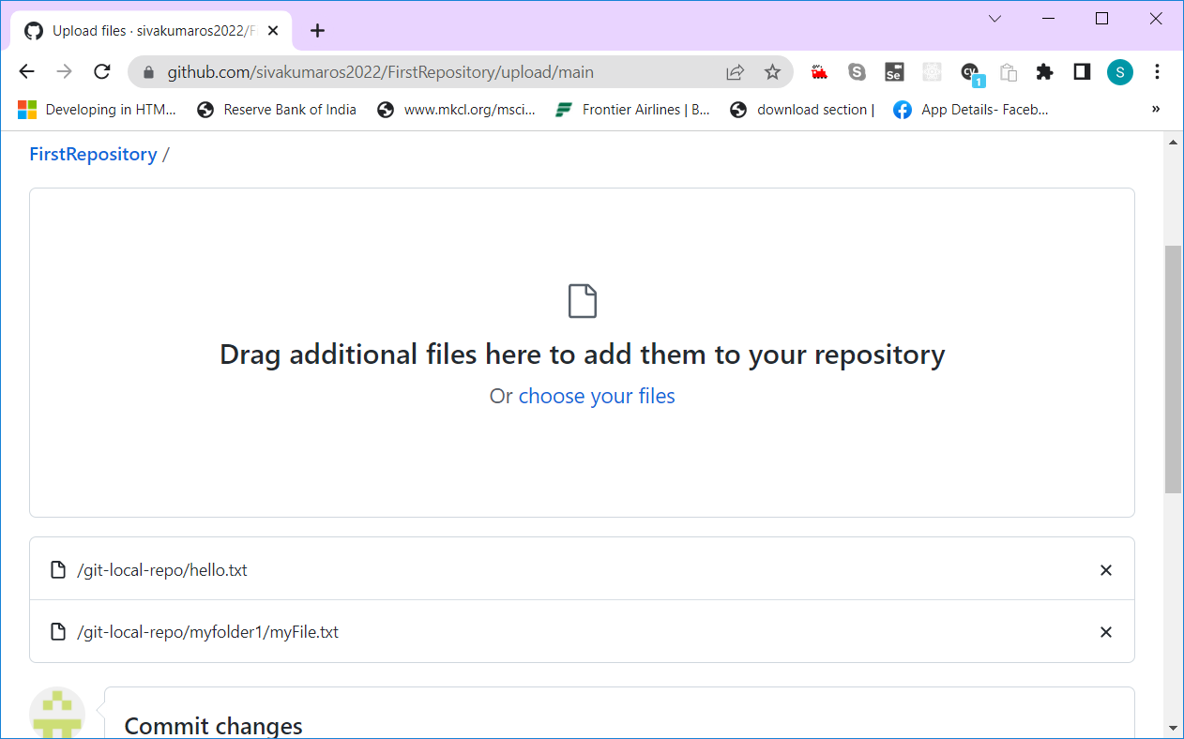

Click on the “Commit Changes” button to save it permanently

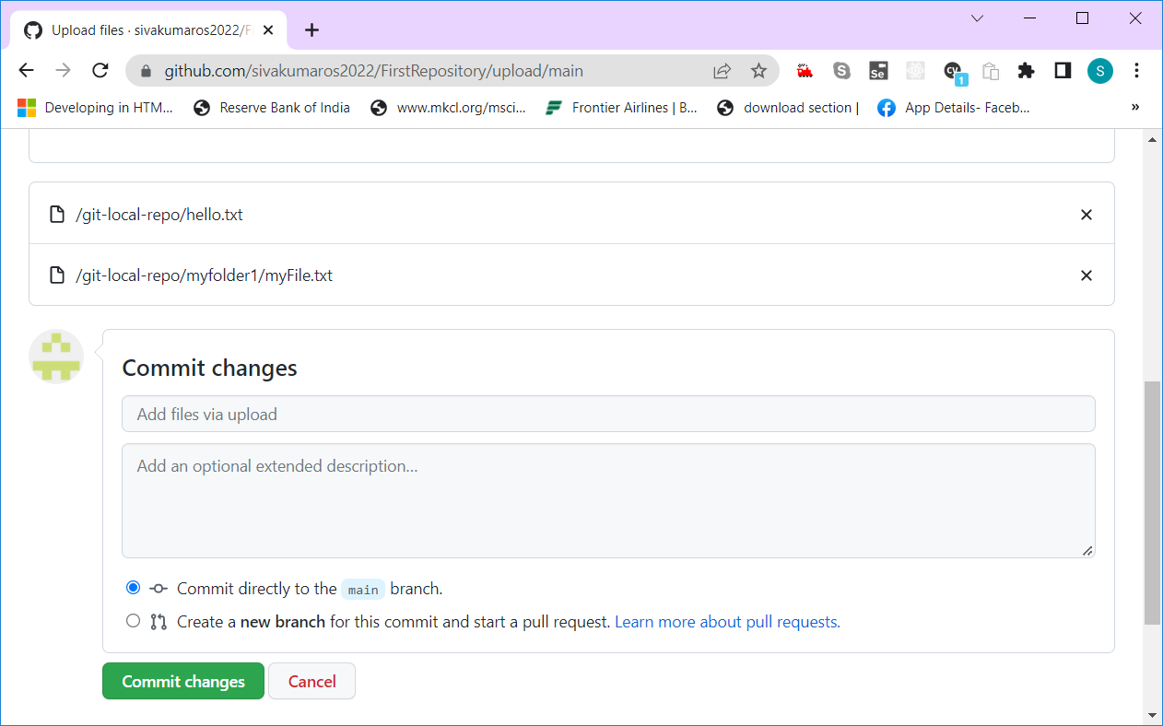

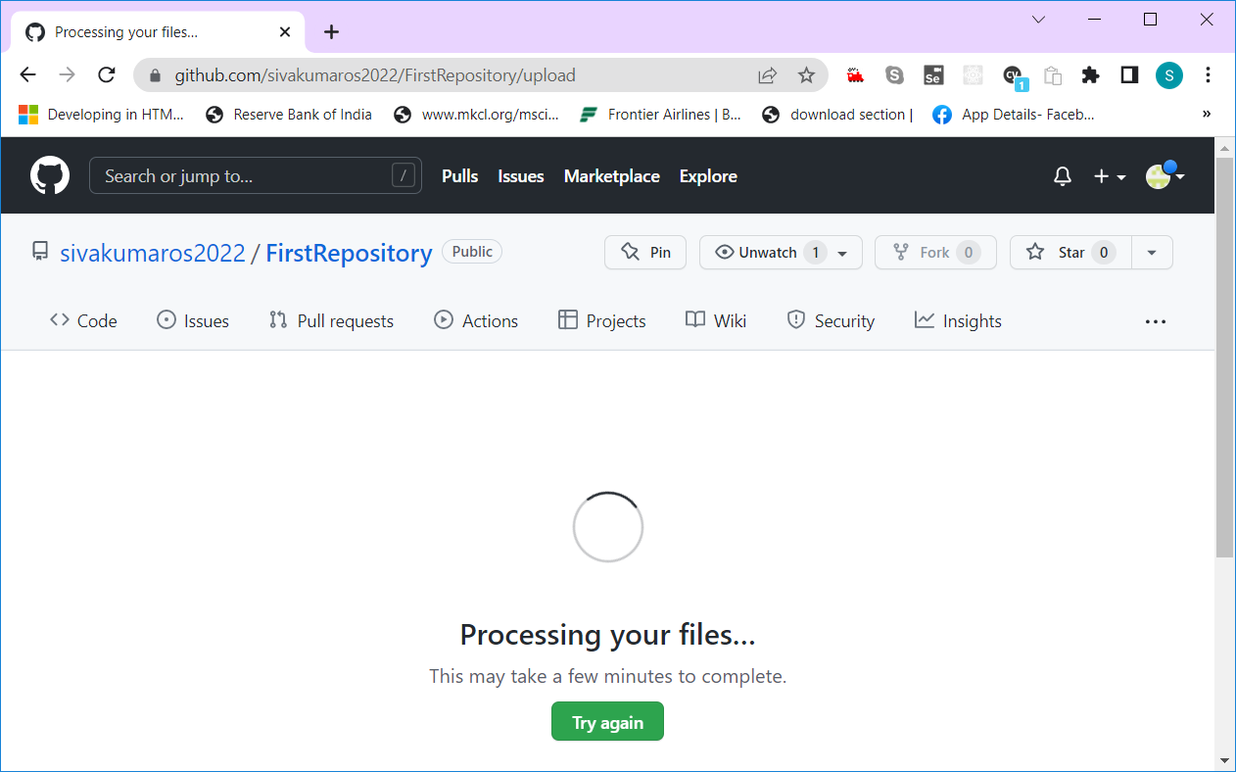

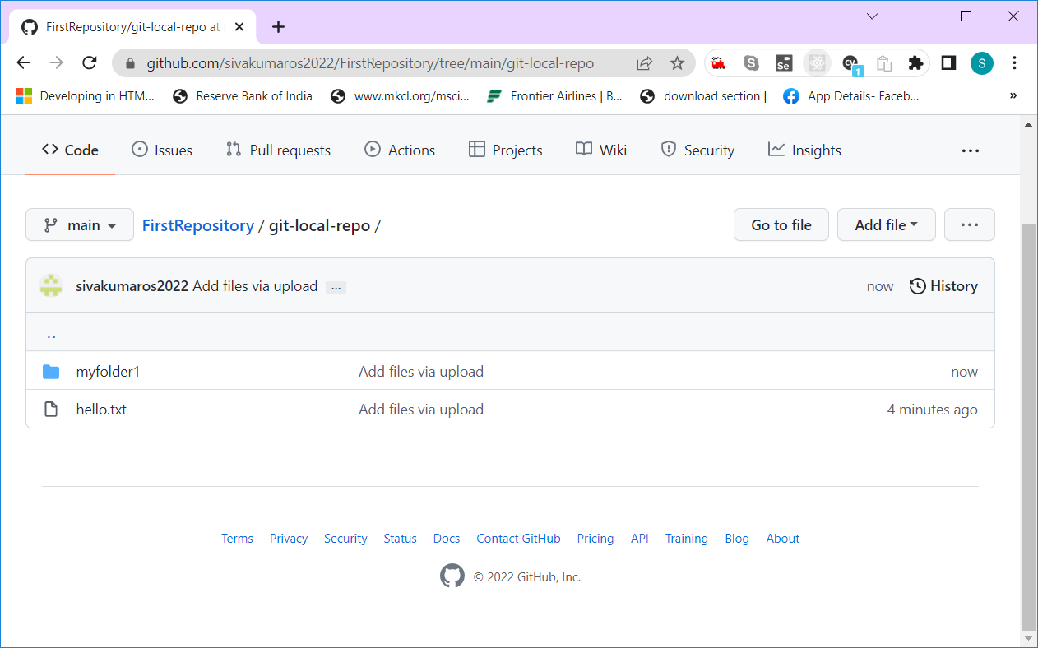

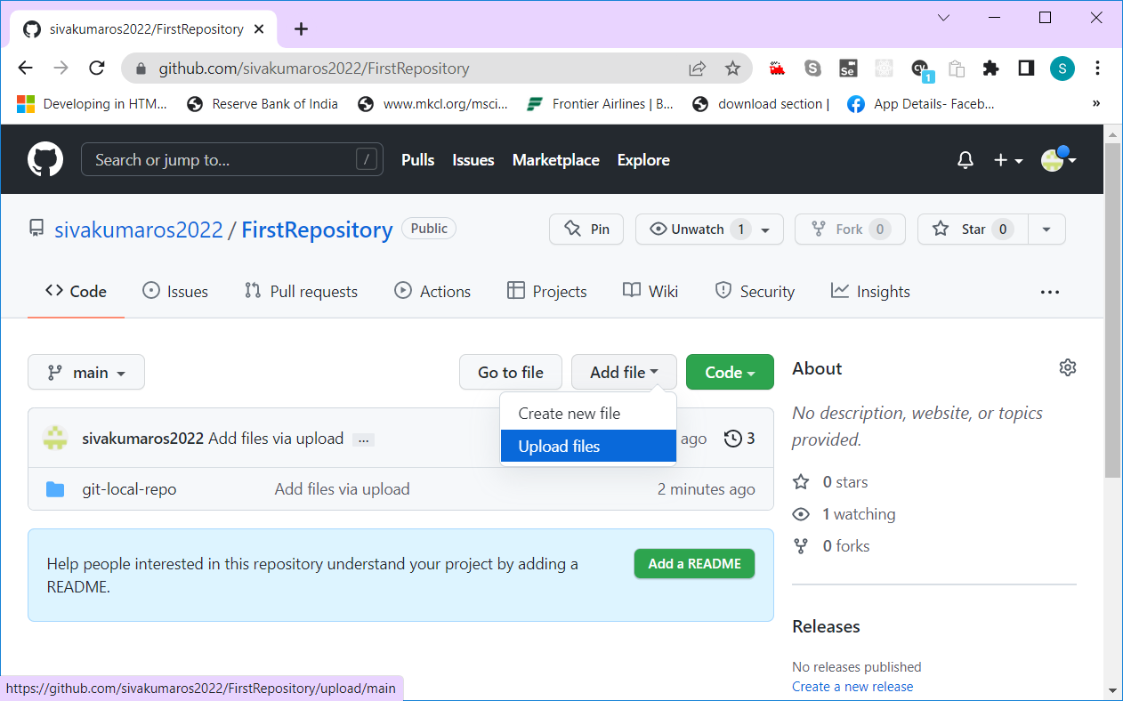

**create a new repository on the command line**

echo "# FirstRepository" >> README.md

git init

git add README.md

git commit -m "first commit"

git branch -M main

git remote add origin https://github.com/sivakumaros2022/FirstRepository.git

git push -u origin main

**push an existing repository from the command line**

git remote add origin https://github.com/sivakumaros2022/FirstRepository.git

git branch -M main

git push -u origin main

The name of the github default branch is “main”.

AWS – Amazon Web Service

Amazon is a company, They provide various services.

They are into Online shopping business

They are also manufacturing many products (Electronic items, household items etc.,)

They are Cloud Service Providers

Web Service – It’s a Service offered with the help of Internet.

Similar to github, we can create a free-tier account for aws.

Aws.amazon.com -- <https://aws.amazon.com/> -- This is amazon web service url.

Creating a Free-tier account in AWS

1. Open aws.amazon.com in browser

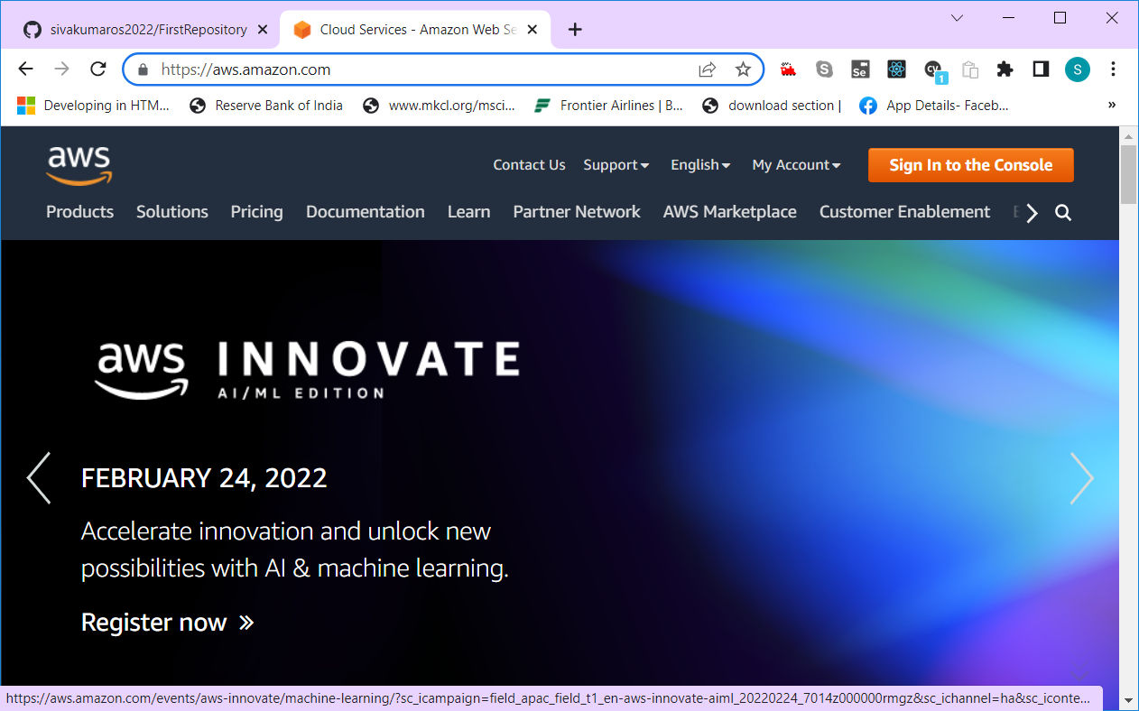

1. Click on “Sign in to the Console” button on top right corner

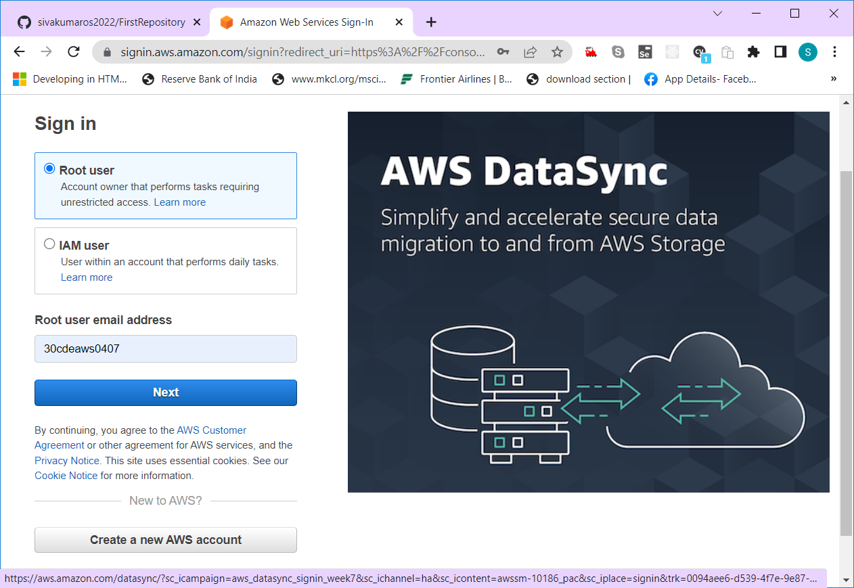

1. Click on “Create a new AWS account” button, you will see a signup page as shown below

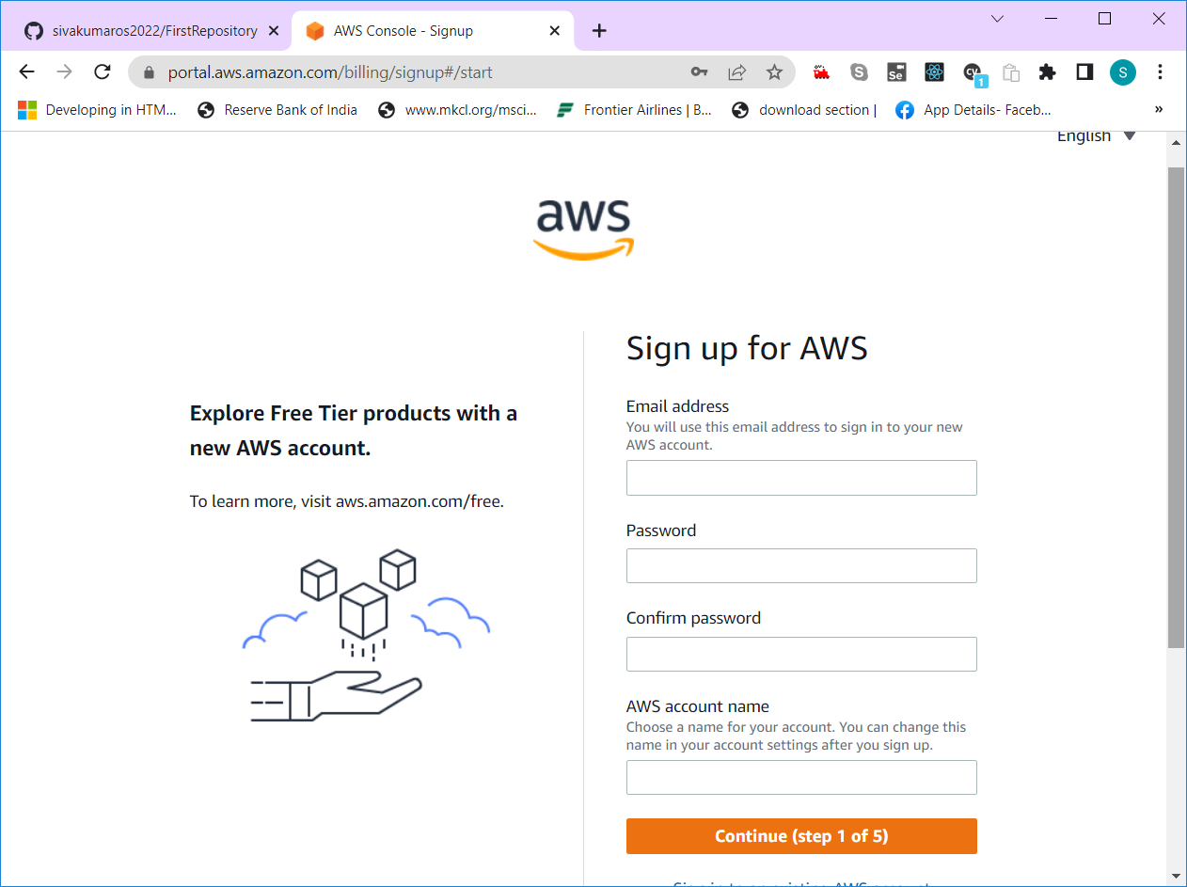

1. Fill all the details in signup form and click “Continue” button

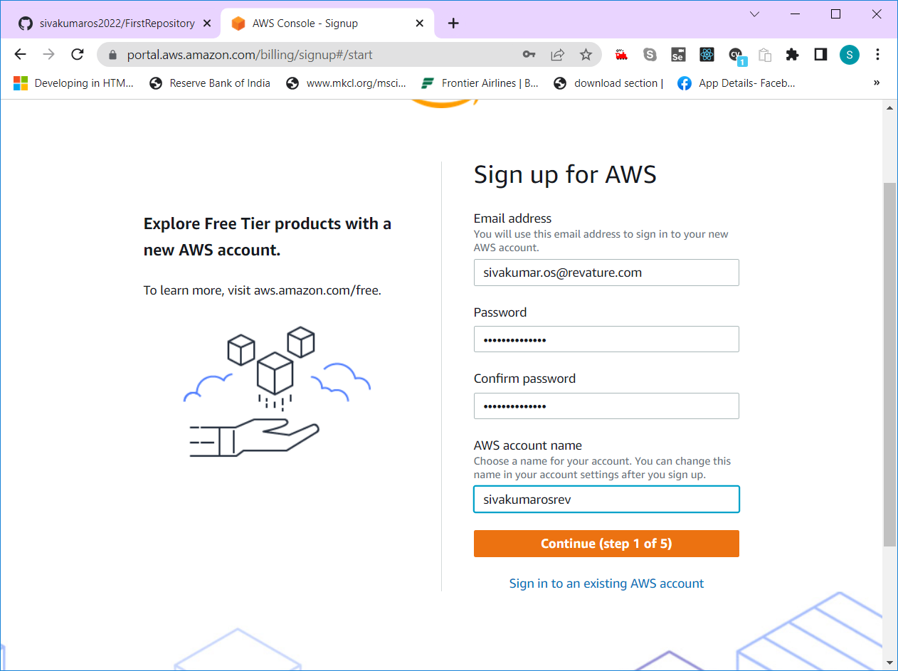

1. Complete the security check by filling a captcha

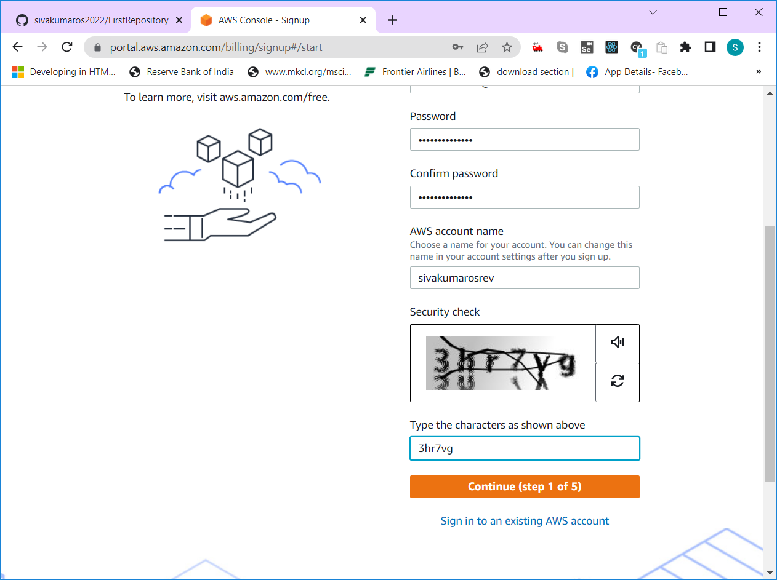

1. Fill contact details in the following

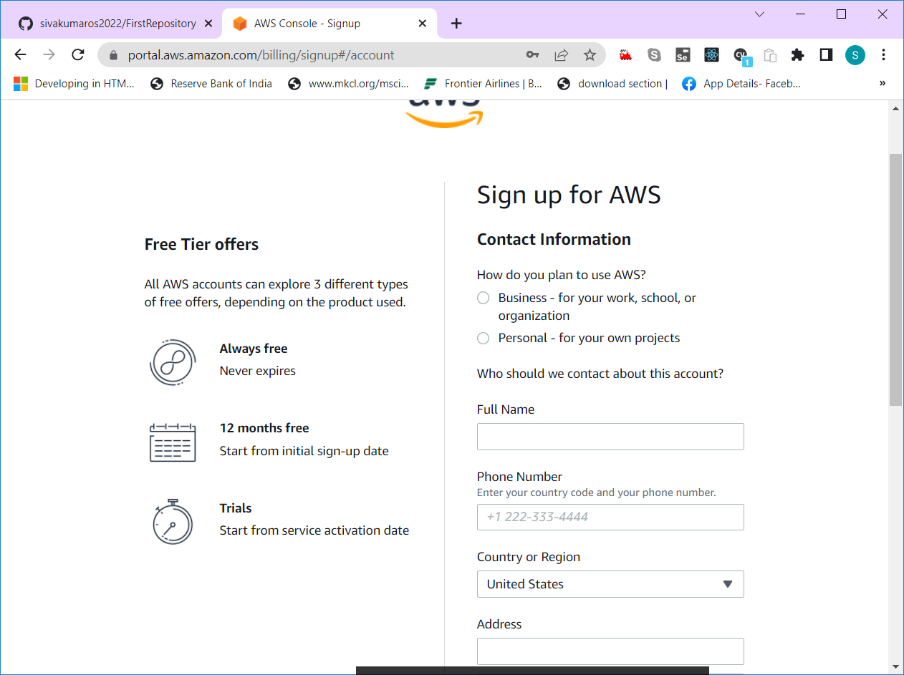

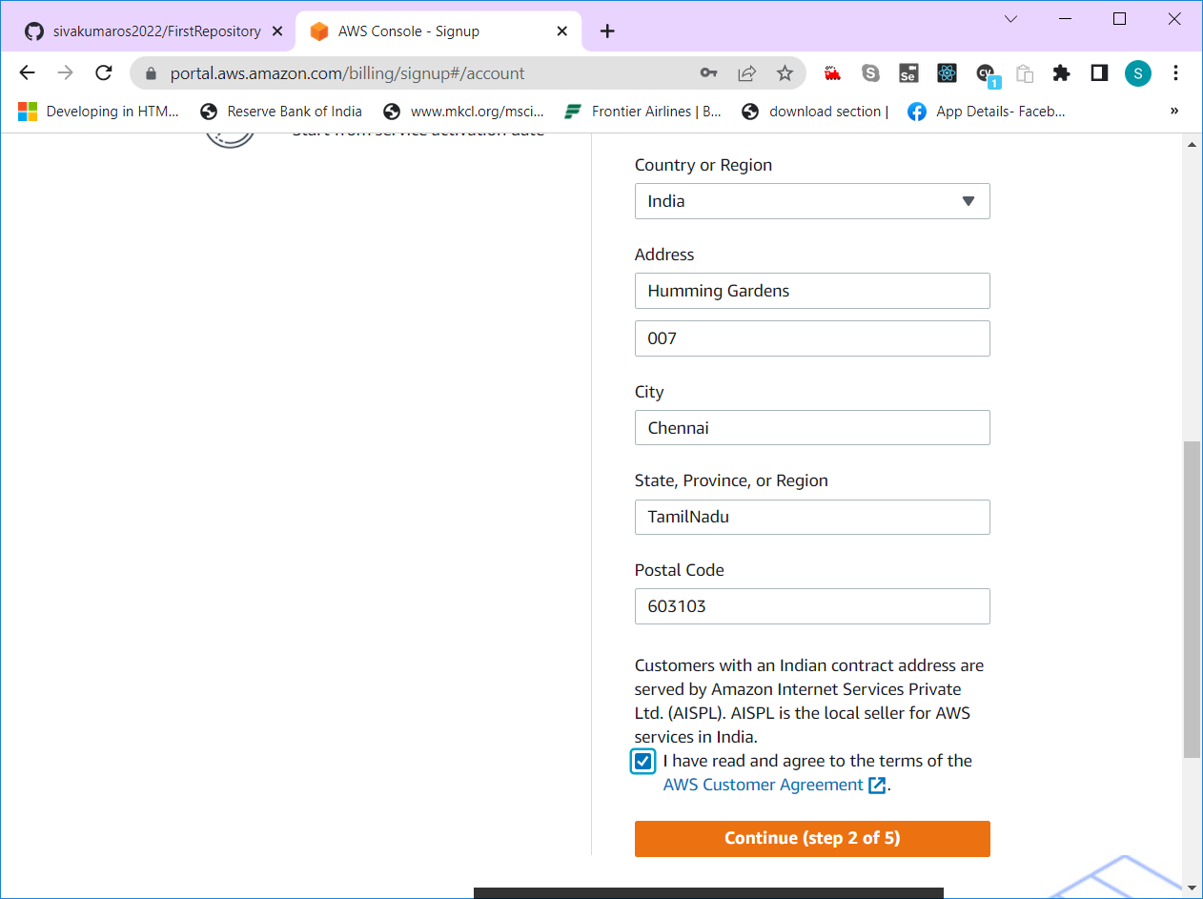

1. In the next form, fill Billing details (Very important step)

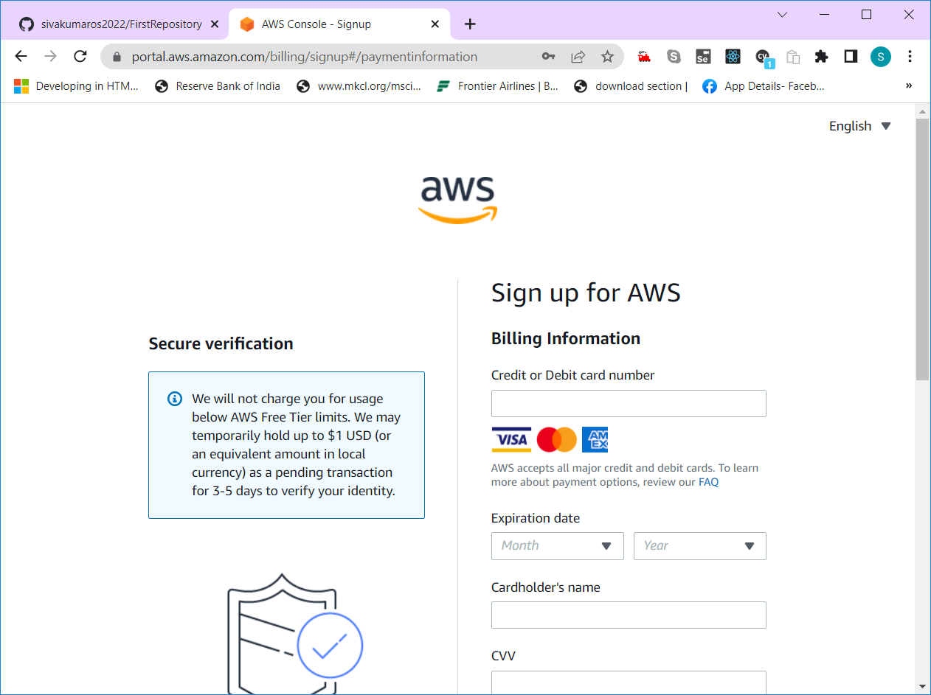

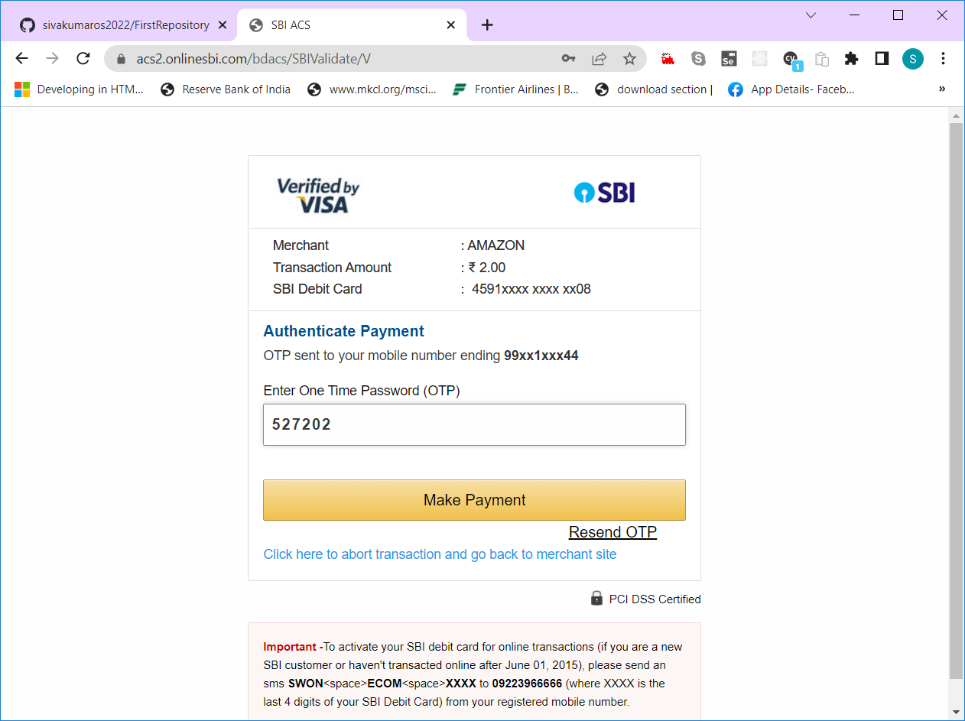

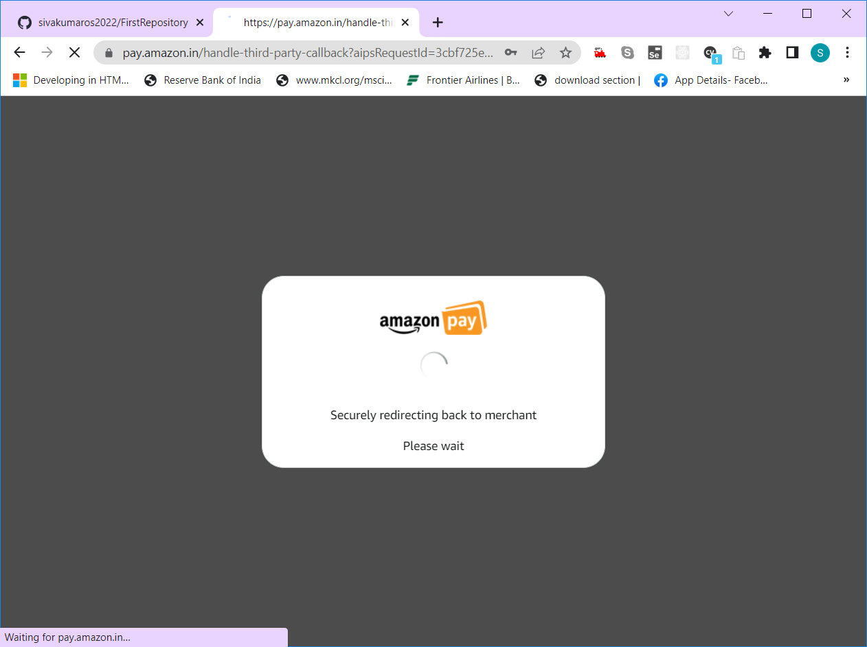

Confirm your identity by providing valid phone number.

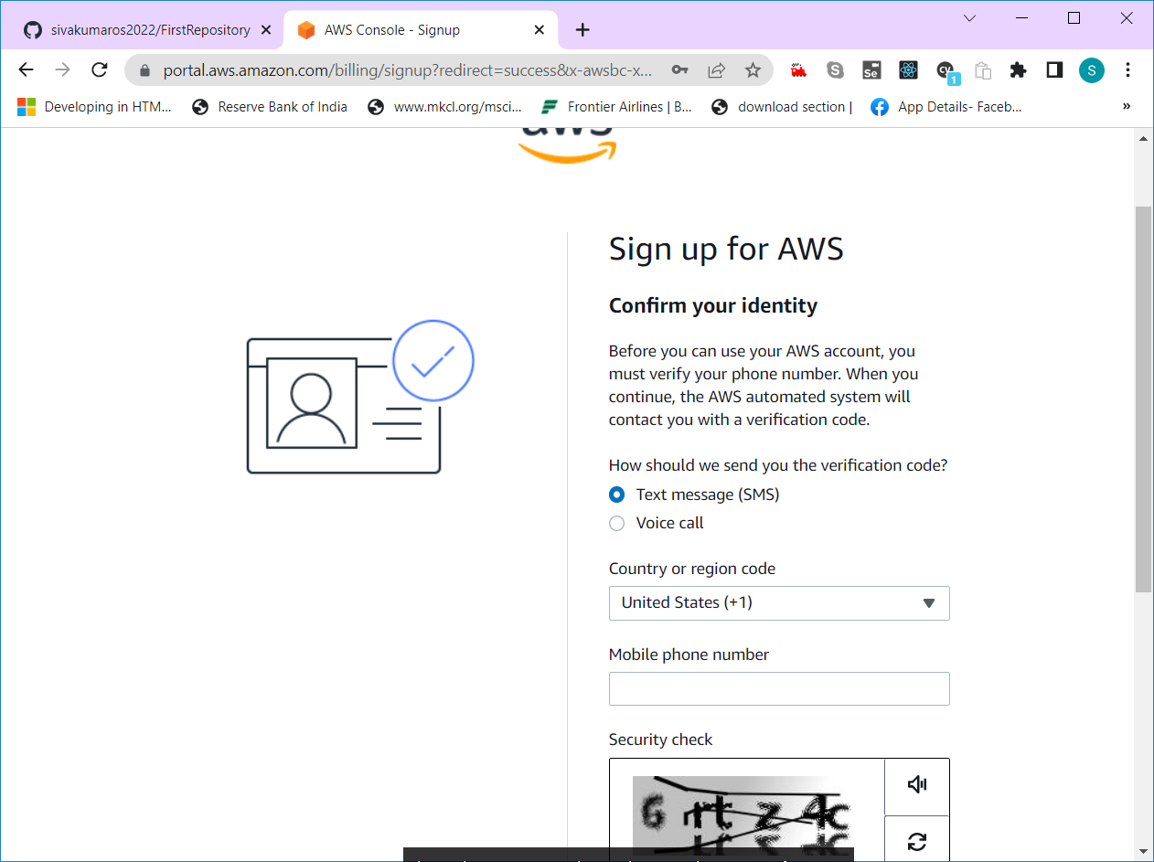

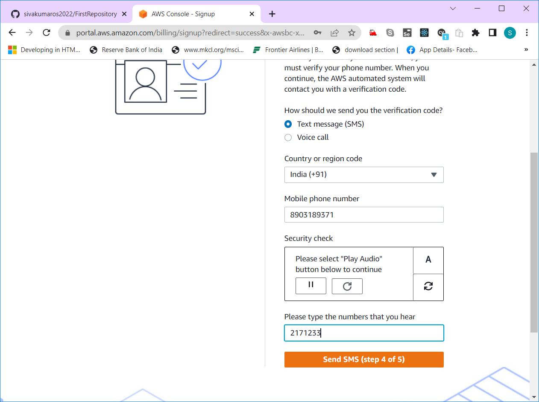

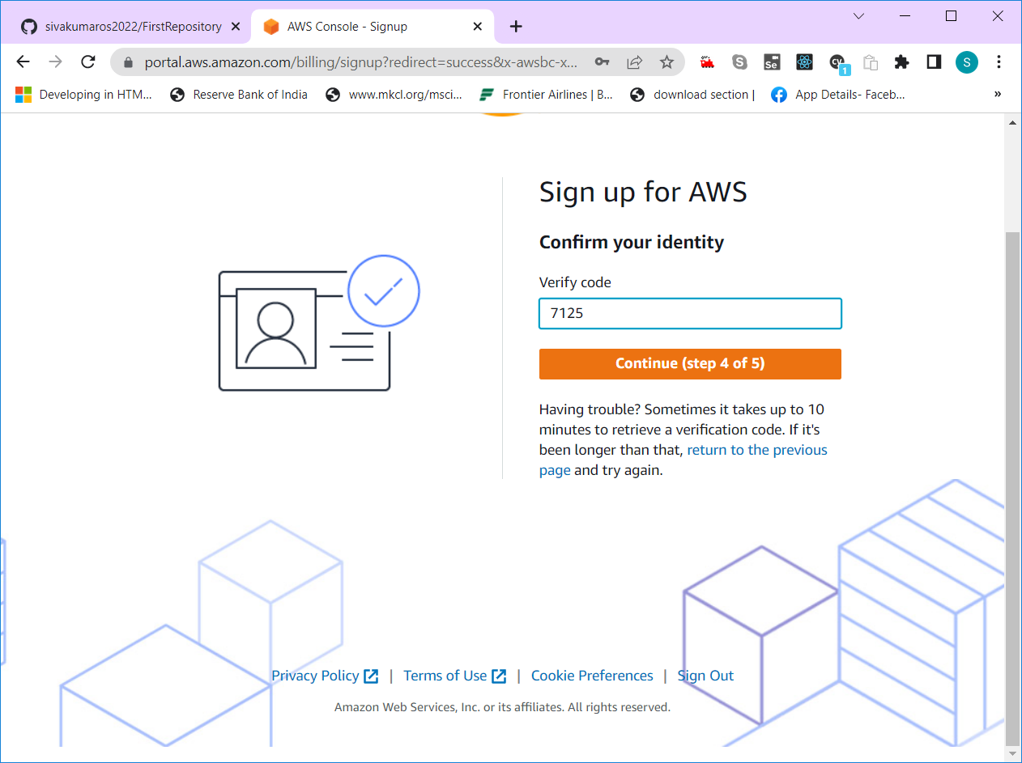

Select basic support plan for free account

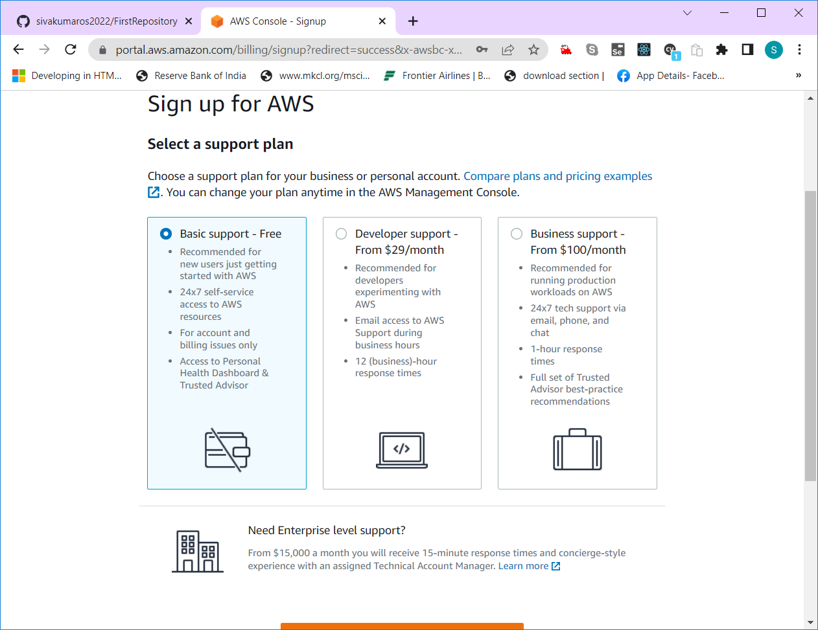

Finally click on “Complete Signup” button

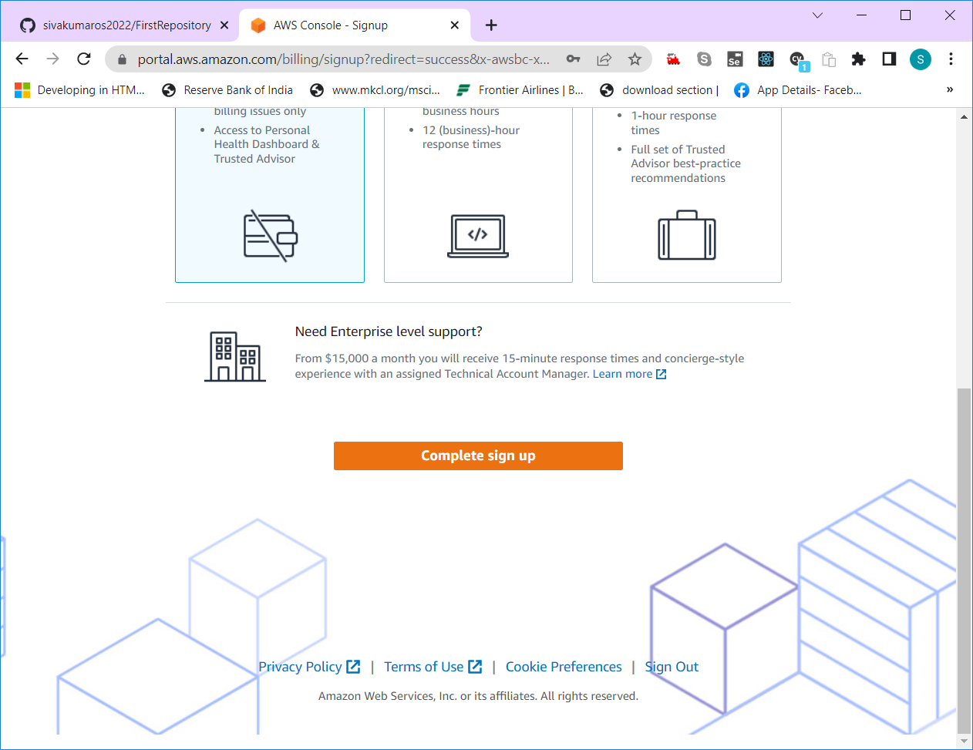

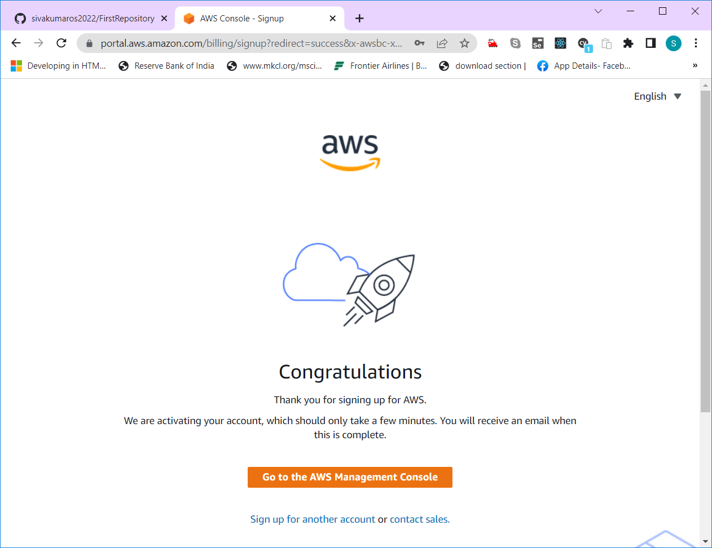

Then click on “Go to the AWS Management Console” button

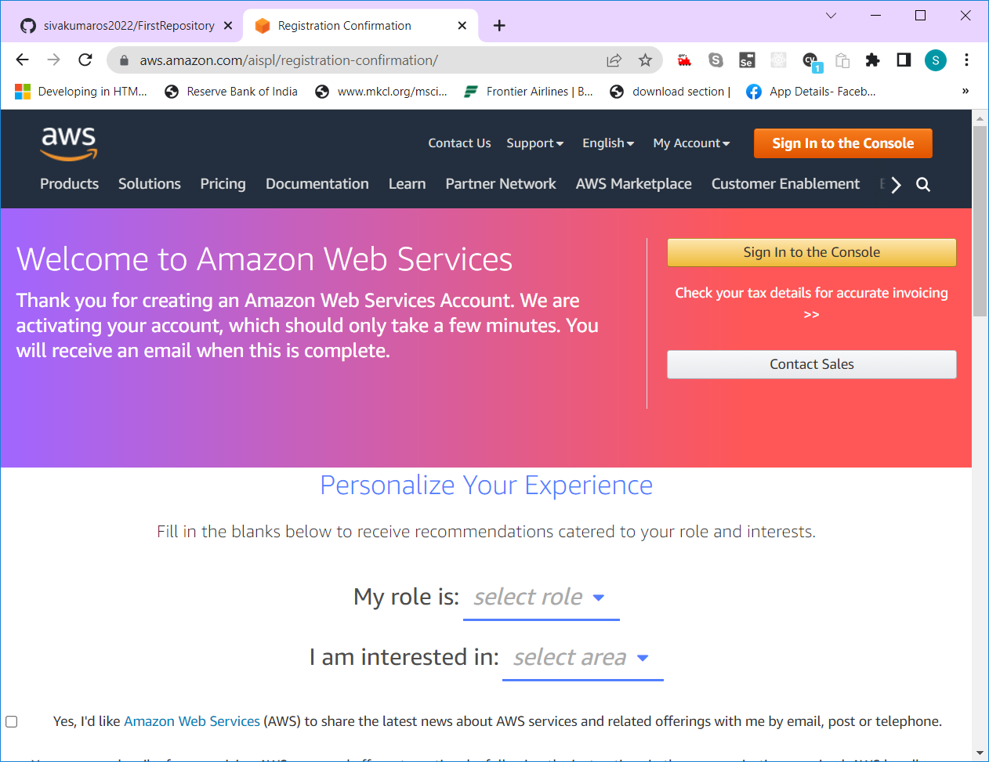

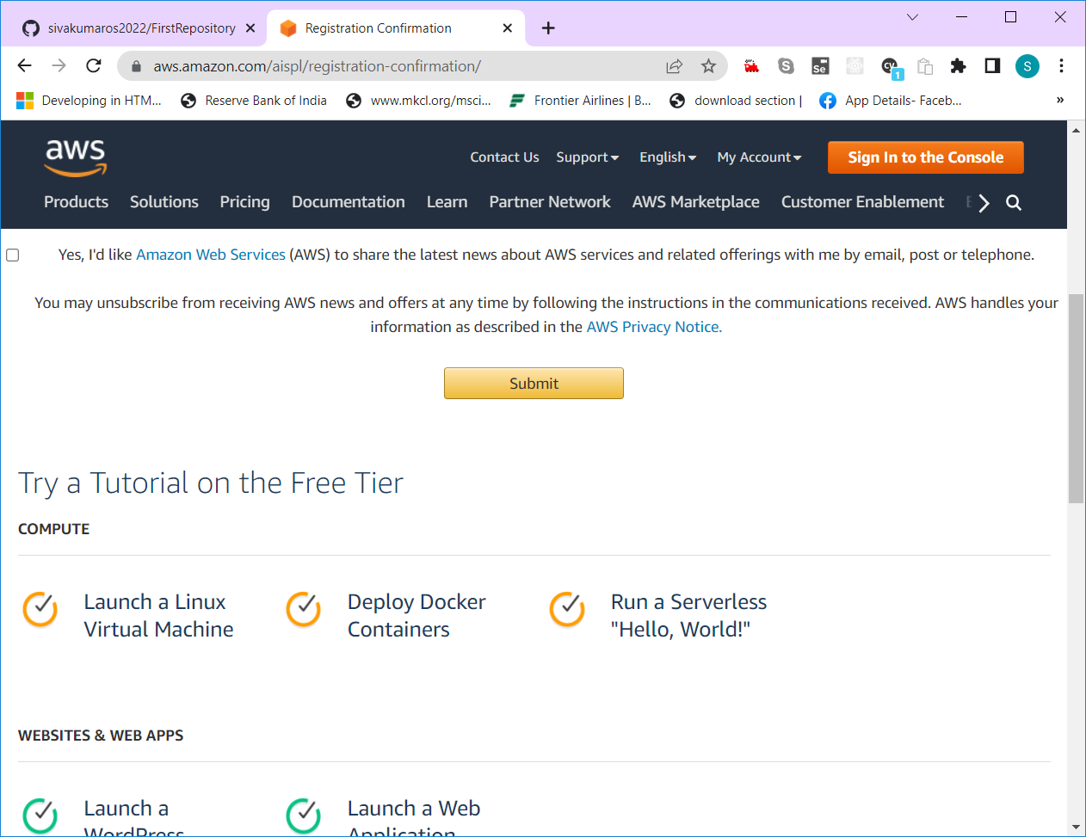

After clicking submit button, click on “Sign in to Console” button

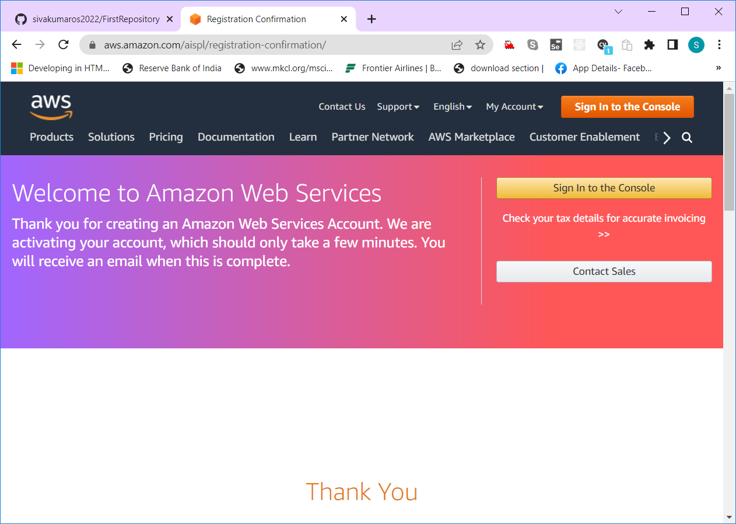

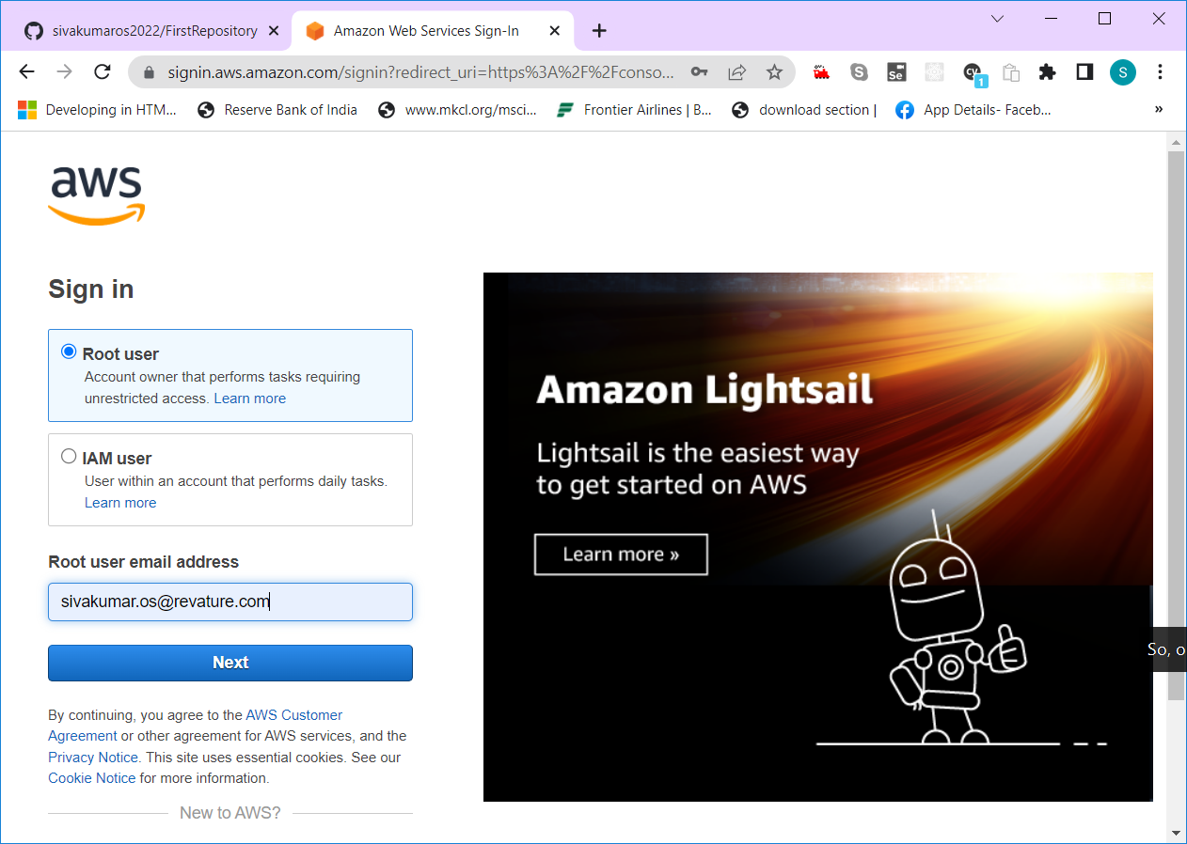

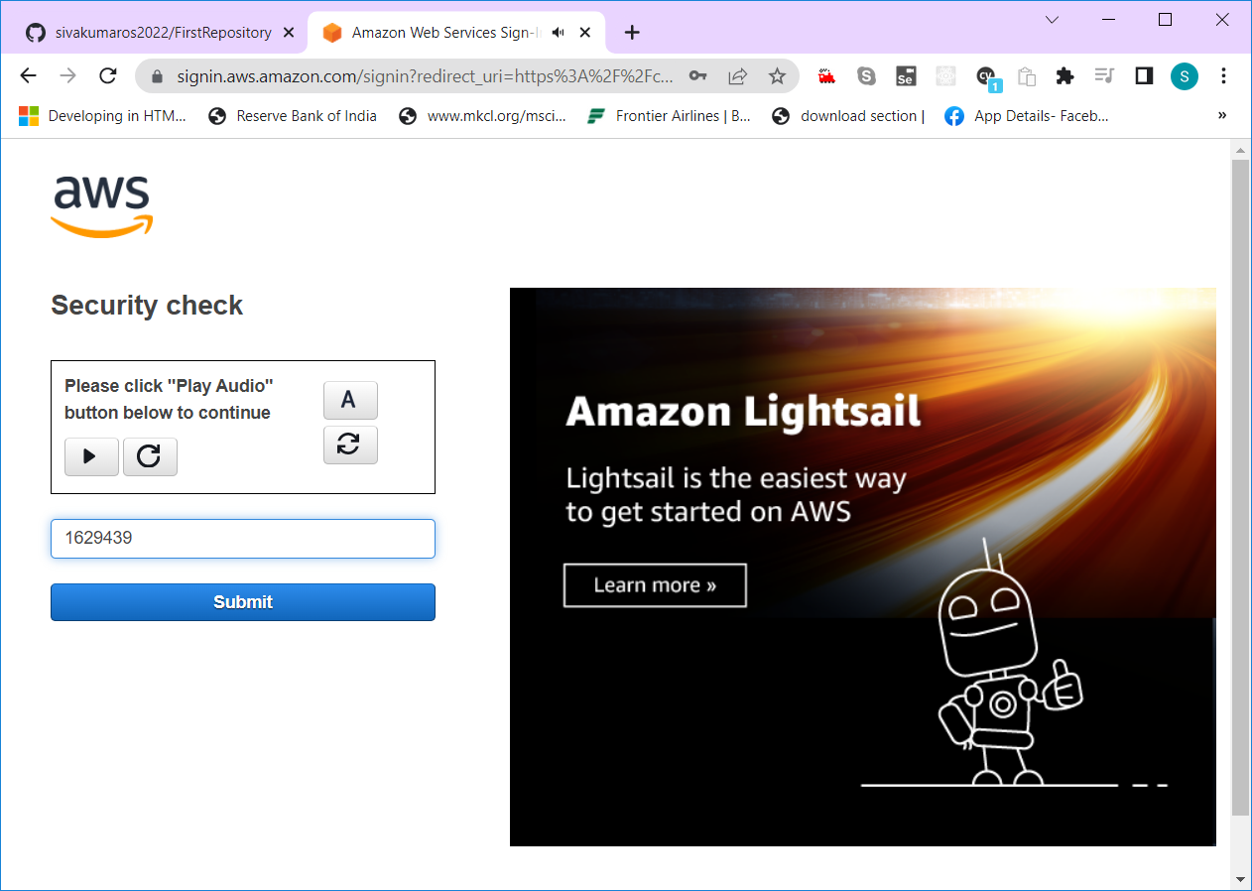

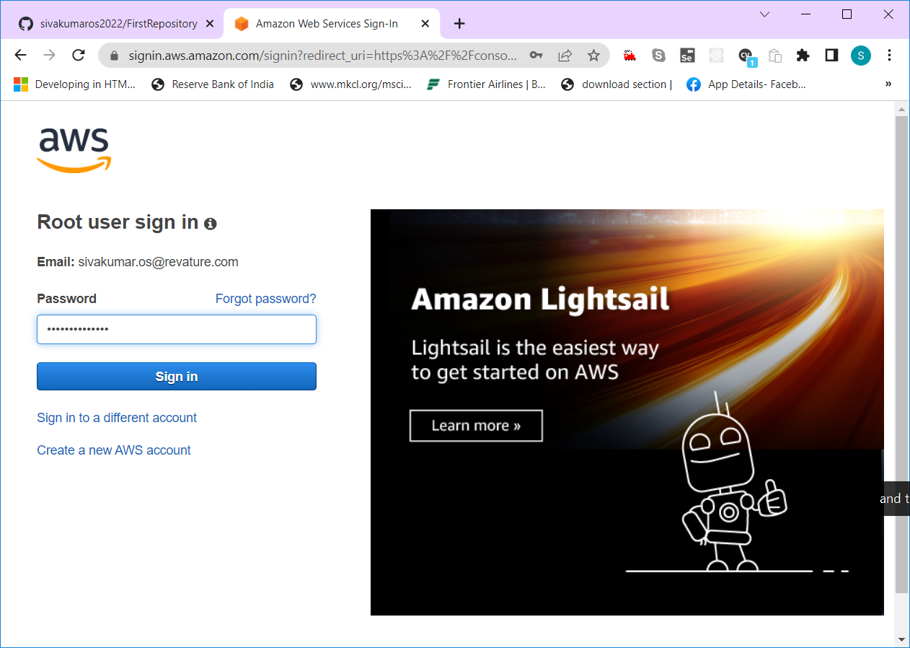

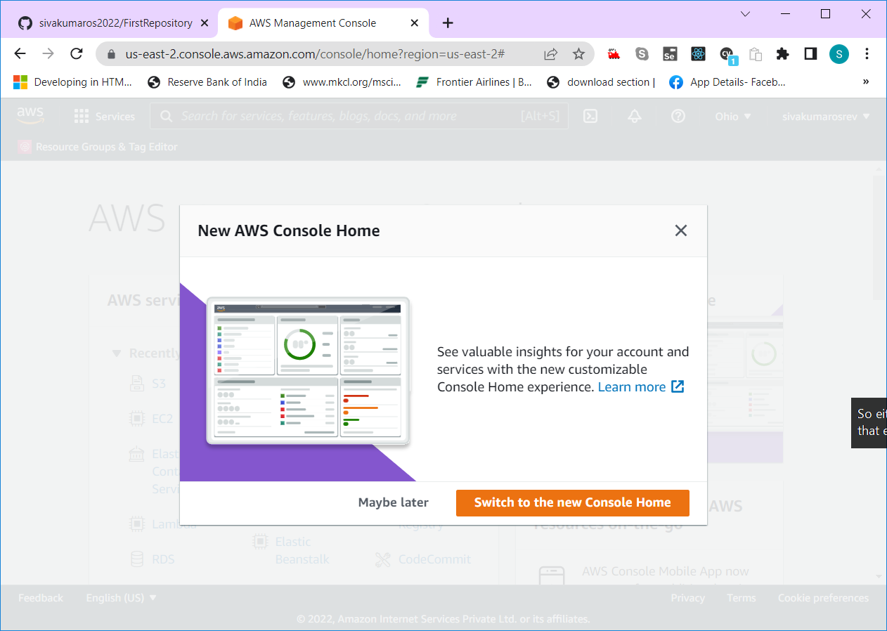

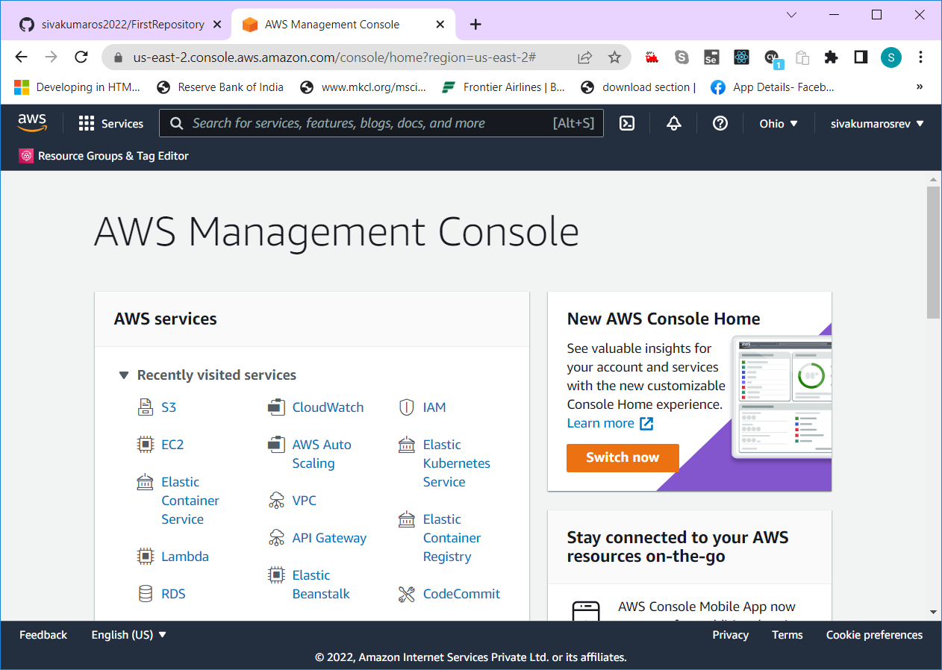

Why AWS?

Many Services are available in cloud.

Type of Cloud Service

1. IaaS (Infrastructure as a Service) – Only Hardware
2. PaaS (Platform as a Service) – Hardware + OS – Tools to compile, test & run the application
3. SaaS (Software as a Service) – Gmail, Office365, Adobe tools

Infrastructure -- Hardware

Personal Computer Configuration

1. Processor (Multi-Core, Speed GHz, (MIPS))
2. RAM Capacity (4GB/8GB/16GB/32GB)
3. ROM Capacity
4. HDD (Magnetic/SSD – 250GB- 2TB)
5. WebCam, Modem, Various ports like usb, hdmi, audio port
6. Mic, Speaker, Finger print reader, printer
7. Monitor

Server -- initial cost of purchasing the server system will be very high.

Startup company – They could not able to spend huge money (investment) on infrastructure.

Hardwares, Network devices router, switches, hub, ports

Instead of buying a house, we can take it for rent. 2.5 millon $, rent 2500

AWS – Amazon Web Service

AMI – Amazon Machine Image

EC2 – Elastic Compute Cloud (Virtual Machine)

ECS – Elastic Container Service

EKS – Elastic Kubernetes Service

S3 – Simple Storage Service

RDS – Relational Database Service

IAM – Id and Access Management

Two types of Cloud

1. Private cloud (On-prem data center) – dedicated virtual system.
2. Public cloud (Shared resources)

AWS – Multiple Region – Geographical space coverage by a data center.

AWS – Data Center